ECE 4213/5213

Homework 3

Author: Jonathan Ifegunni

1a. After the program p2_2 with the 3 stated frequency, the following data was generated:

1. f = 0.05

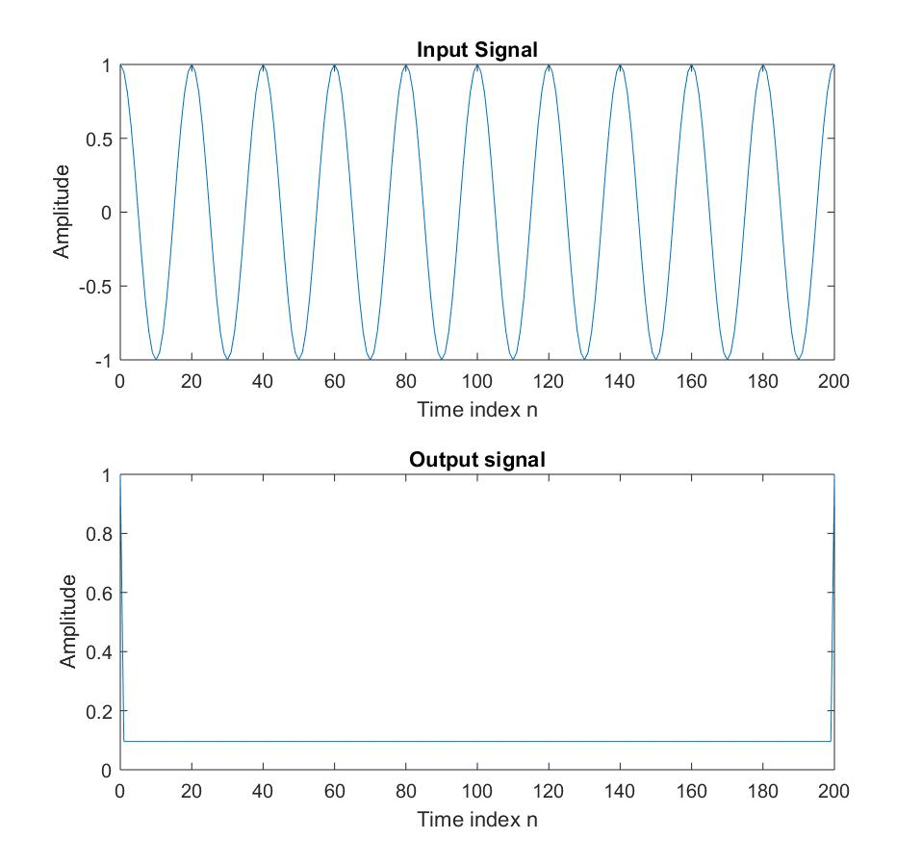

ii) f = 0.10

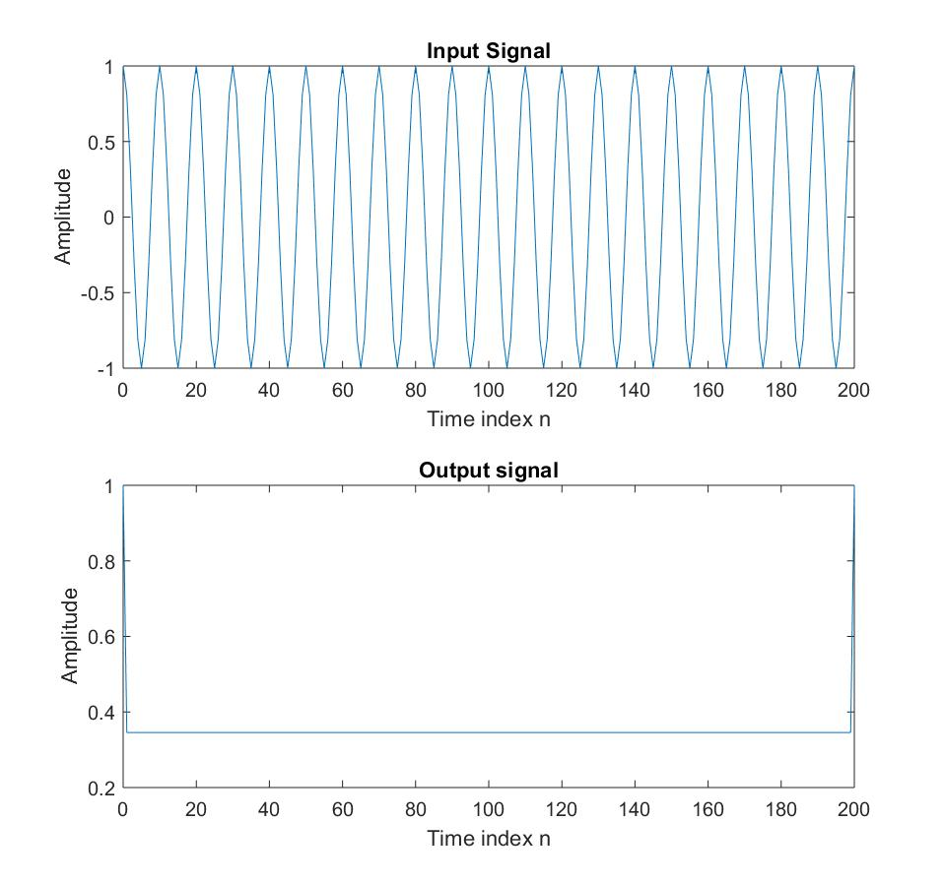

3) f = 0.25

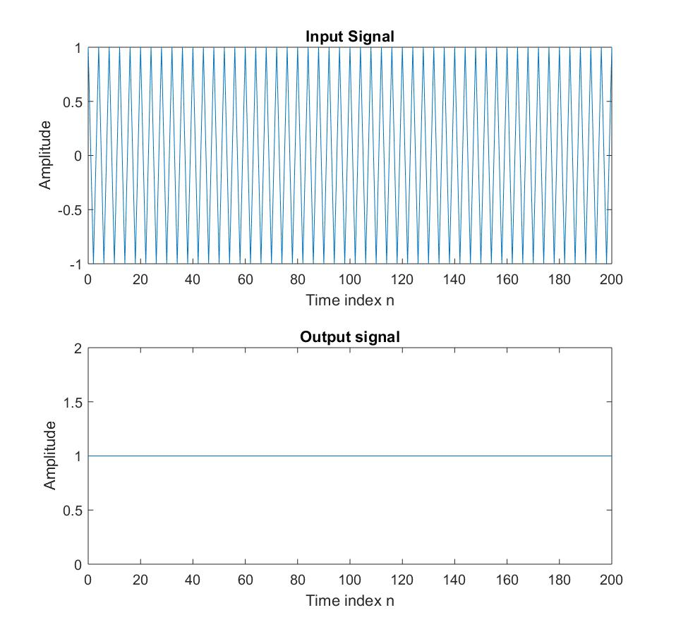

2a) Below is the modified program for P2_2

% Program Q2_6

% Modified version of P2_2 to make the input a cosine plus a constant.

clf;

n = 0:200;

K = 0.5;

f = 0.1;

arg = 2*pi*f*n;

x = cos(arg) + K;

% Compute the output signal

x1 = [x 0 0]; % x1[n] = x[n+1]

x2 = [0 x 0]; % x2[n] = x[n]

x3 = [0 0 x]; % x3[n] = x[n-1]

y = x2.*x2-x1.*x3;

y = y(2:202);

% Plot the input and output signals

subplot(2,1,1)

plot(n, x)

xlabel('Time index n');ylabel('Amplitude');

title('Input Signal')

subplot(2,1,2)

plot(n,y)

xlabel('Time index n');ylabel('Amplitude');

title('Output signal');

Graph obtained from the above program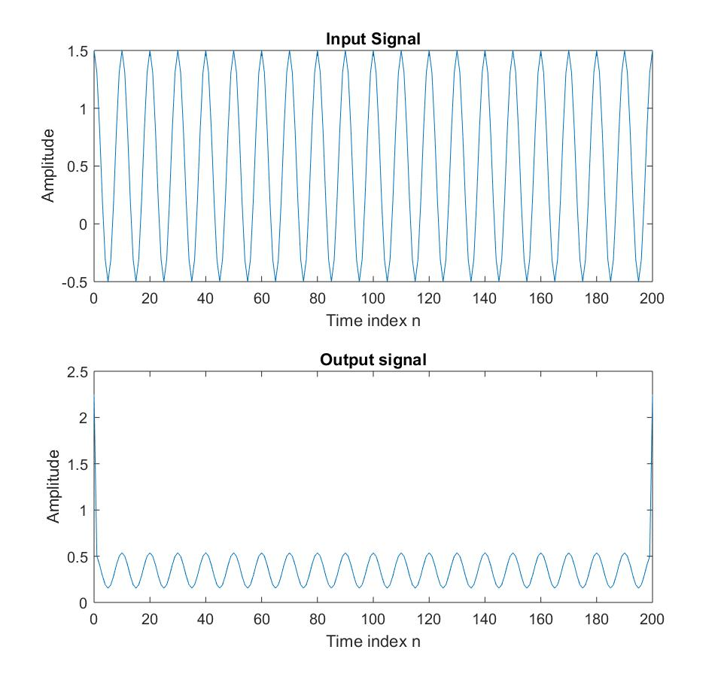

3a) H.M. Hanson ; P. Maragos ; A. Potamianos, “A system for finding speech formants and modulations via energy separation” IEEE Transactions on Speech and Audio Processing, 1994, Vol: 2, Issue: 3 pp: 436 – 443

3b)

% Program DESA1

% Implement the DESA-1 discrete energy separation algorithm

clear;

clf;

% Generate the input signal

n = 0:250;

A = 5.0;

f = 0.1;

w = 2*pi*f;

x = A*cos(w*n);

x2 = [0 x 0]; % zero pad x[n]

y = [0 x 0] - [0 0 x]; % y[n] = x[n] - x[n-1]

z = [x 0 0] - [0 x 0]; % z[n] = x[n+1] - x[n]

% TK operator on y[n]

y1 = [y 0 0]; % y[n+1]

yn = [0 y 0]; % y[n]

ym = [0 0 y]; % y[n-1]

P_y = yn.*yn-ym.*y1;

% TK operator on z[n]

z1 = [z 0 0]; % z[n+1]

zn = [0 z 0]; % z[n]

zm = [0 0 z]; % z[n-1]

P_z = zn.*zn-zm.*z1;

% TK operator on x[n]

x21 = [x2 0 0]; % x2[n+1]

x2n = [0 x2 0]; % x2[n]

x2m = [0 0 x2]; % x2[n-1]

P_x2 = x2n.*x2n-x2m.*x21;

% Resize TK outputs to original size of x[n]

P_y = P_y(3:length(P_y)-2);

P_z = P_z(3:length(P_z)-2);

P_x2 = P_x2(3:length(P_x2)-2);

% Estimate the IA and IF

IFhat = acos(1 - (P_y + P_z)./(4*P_x2))/(2*pi);

IAhat = sqrt(P_x2./(1 - (1 - (P_y + P_z)./(4*P_x2)).^2));

% Plot the input and output signals

figure(1);

plot(n,x);

axis([0 250 -6 6]);

xlabel('Time index n');ylabel('Amplitude');

title('Input Signal');

figure(2);

plot(n,IAhat);

xlabel('Time index n');ylabel('IA a[n]');

title('Instantaneous Amplitude (IA)');

figure(3);

plot(n,IFhat);

xlabel('Time index n');ylabel('IF \omega[n] / (2\pi)');

title('Instantaneous Frequency (IF)');

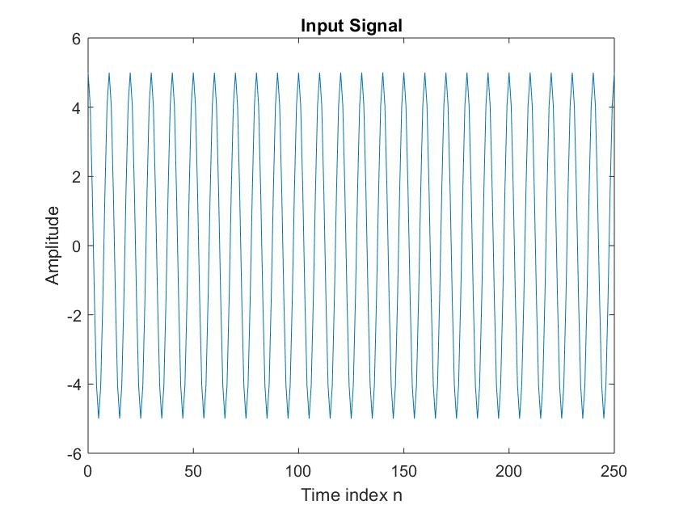

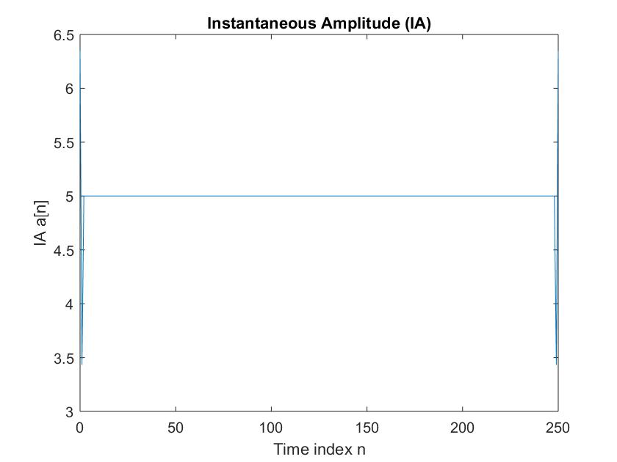

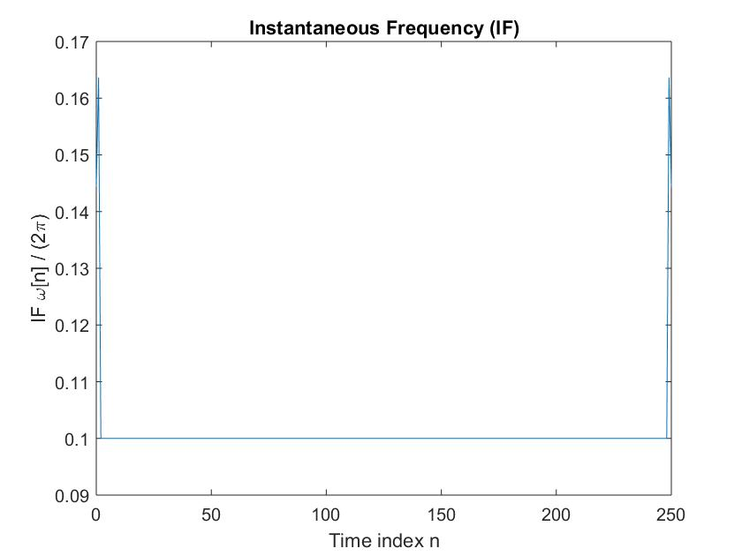

3c)

